**PROJECT REPORT ON**

**RETAIL MANAGEMENT AND SALESFORCE**

1. **INTRODUCTION**

**1.1 Overview**

Retail management involves various activities such as inventory management, sales

application using Salesforce can automate and streamline these activities, making them

more efficient and effective

1.2 Purpose

The purpose of this project is to create a retail management application using

Salesforce that can help retail businesses manage their operations more efficiently. The

application will automate various tasks, such as tracking inventory, sales, and customerdata, to help save time and reduce errors.

1. **PROBLEM DEFINITION & DESIGN THINKING**

**2.1 Empathy Map**

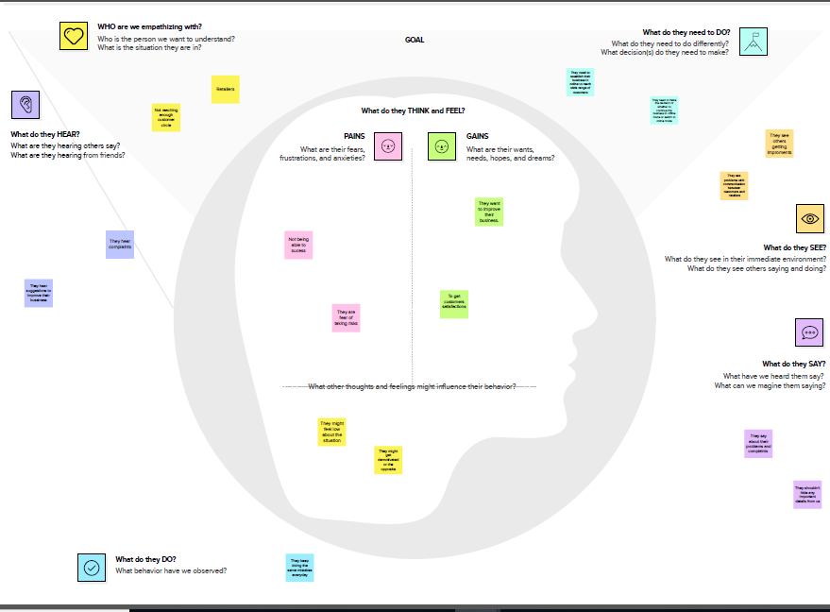

**2.2 Ideation & Brainstorming Map**

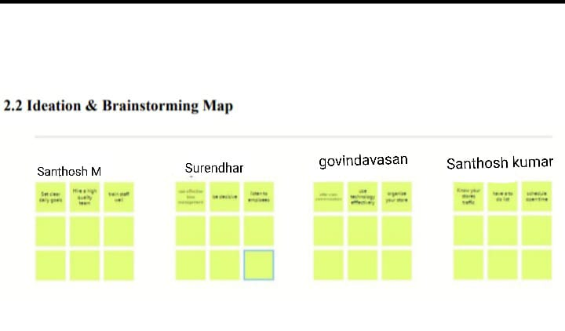

1. **RESULT**

**3.1 Data Model:**

|  |  |
| --- | --- |
| Object name | Fields in the Object |
| Object 1 | |  |  | | --- | --- | | Field label | Data type | | campaigen | We do promotions by using this object | | Leads | We capture leads here | | accounts | We capture leads here | | contacts  opportunities  products  warehouse  Sales order  Dispatch/tracking | Employee data of coustemer  Smb sales orders data  Here was store product details  We capture stocks data  This is an actual order which has invoice details  Orders dispatch related info will be stored here | |
| Object 2 | |  |  | | --- | --- | | Field label | Data type | | cases | Historical problems of customers will be stored here | | accounts | We capture coustomers data | |

**3.2 Activity and Screenshot**

**Milestone 1**

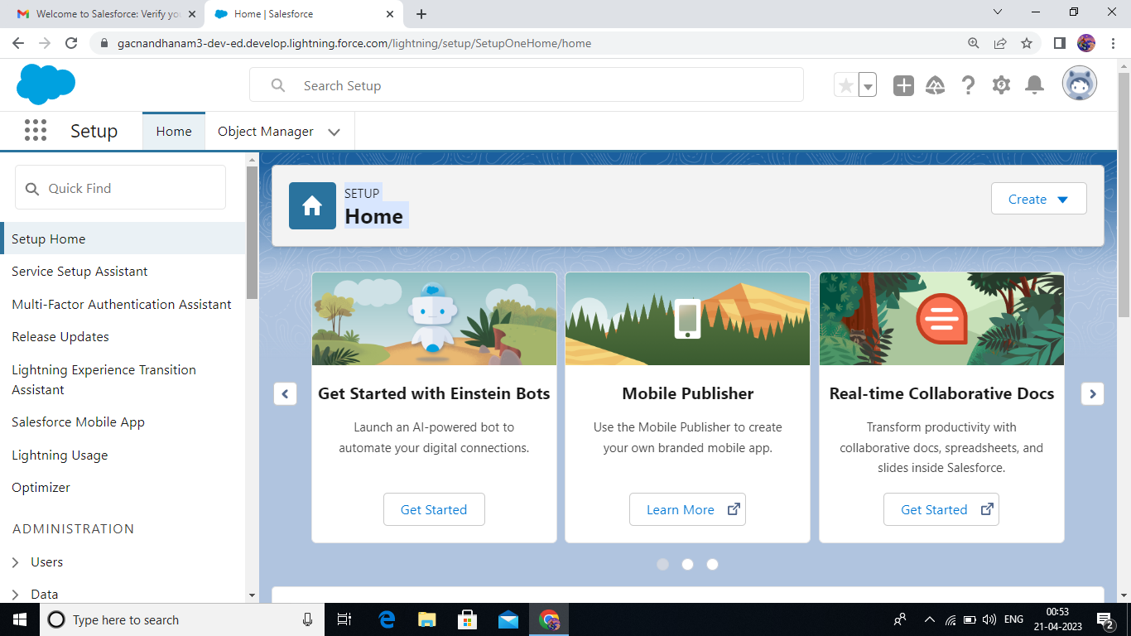

**Milestone 2**

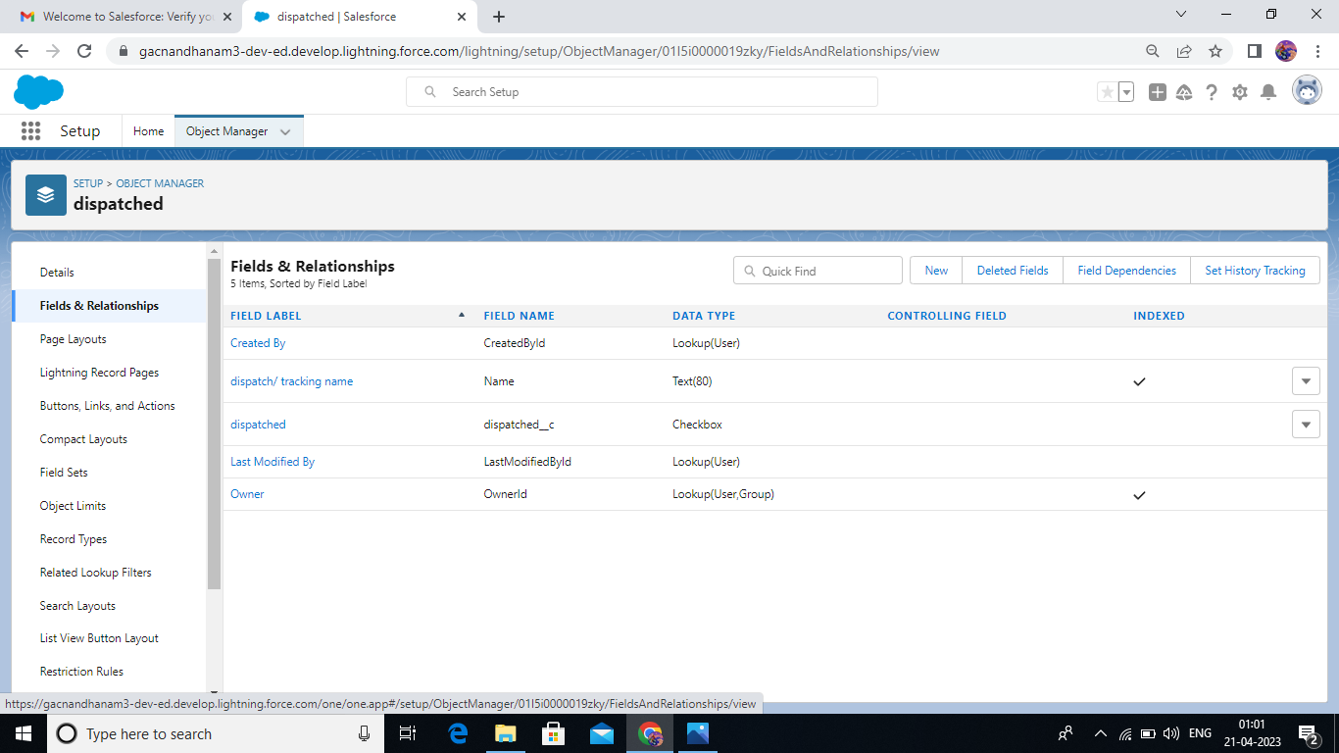

**Milestone 3**

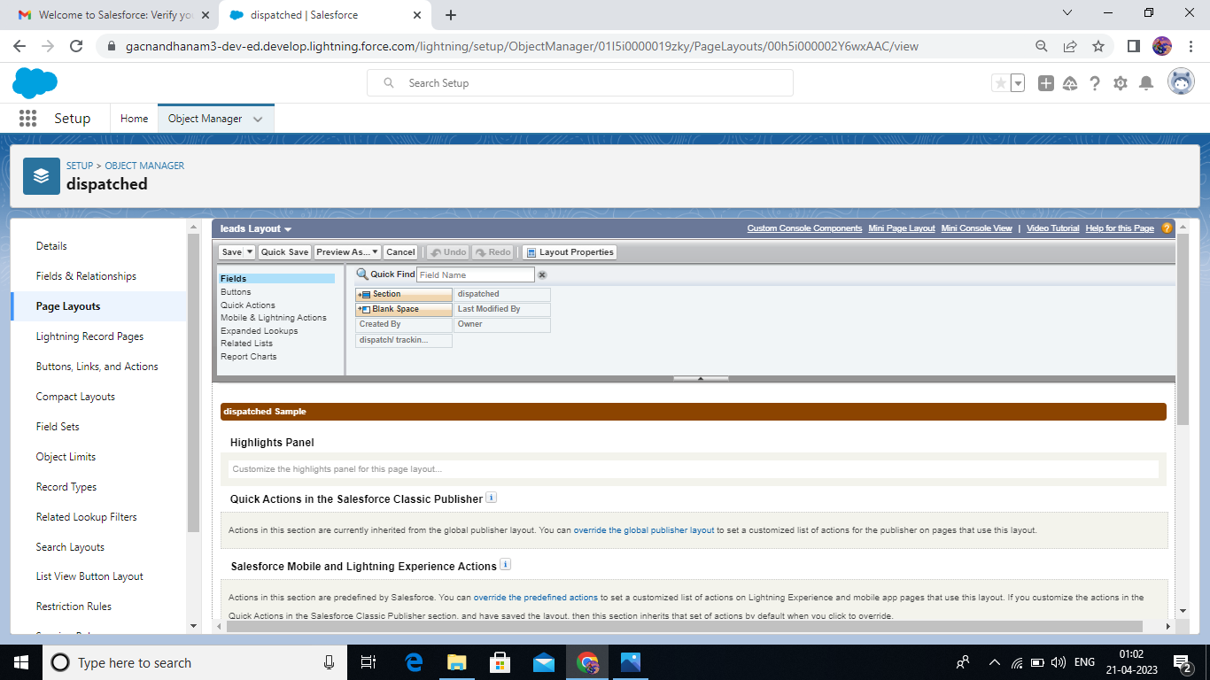

**Milestone 4**

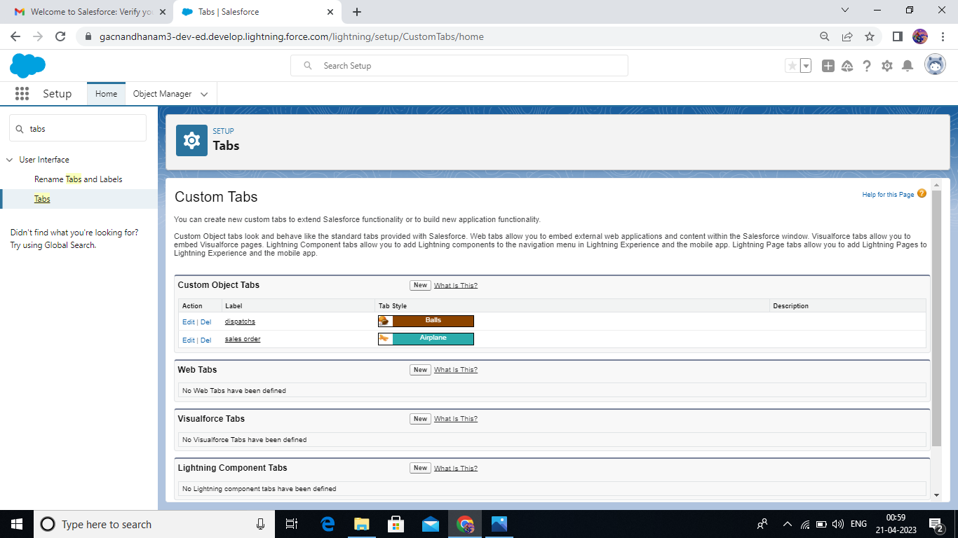

**Milestone 5**

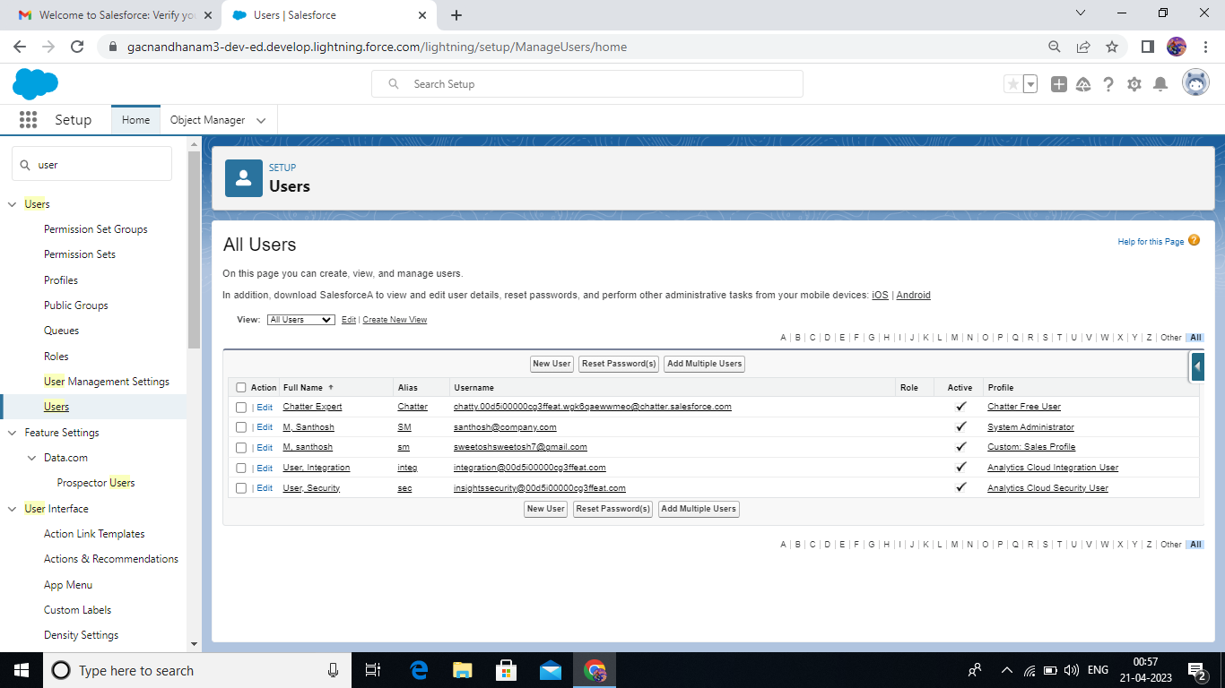

**Milestone 6**

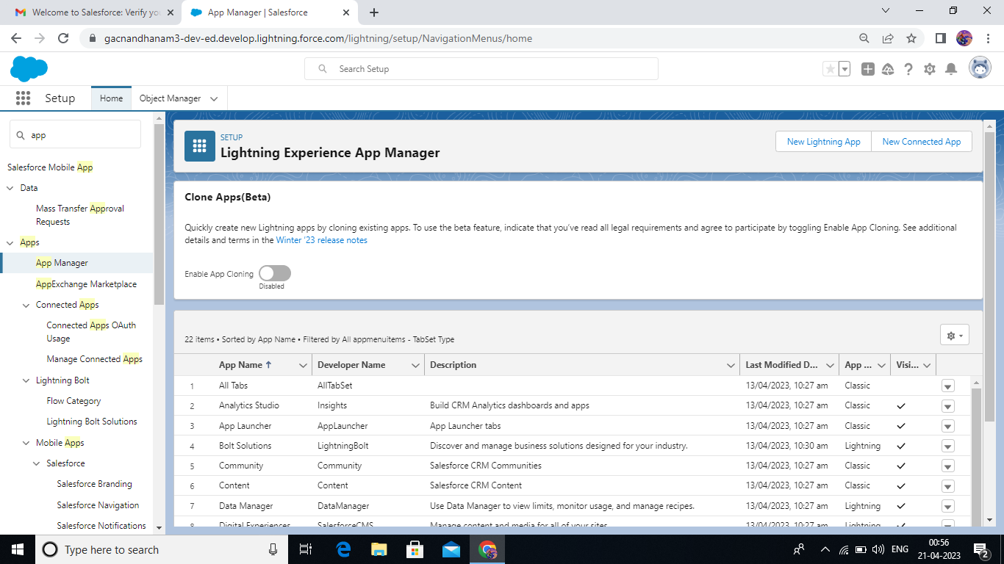

**Milestone 7**

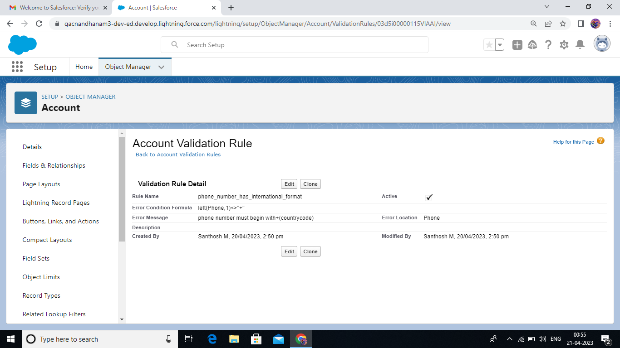

**Milestone 8**

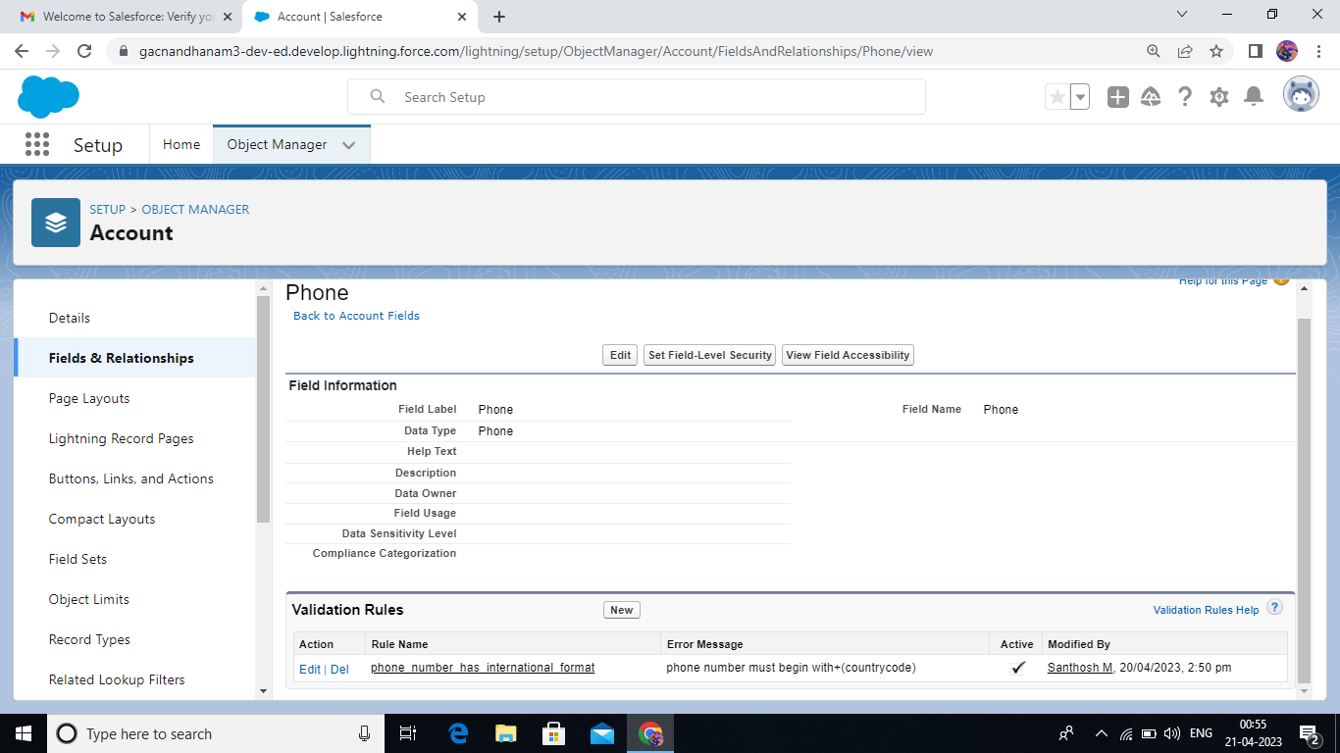

**Milestone 9**

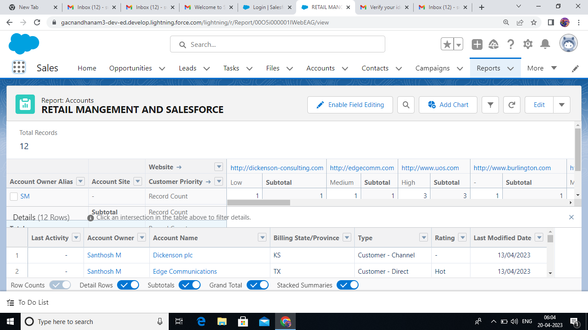

**Milestone 10**

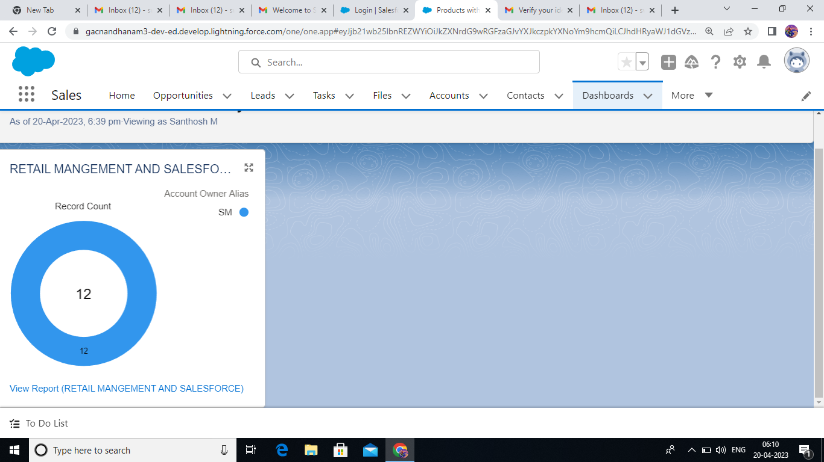

1. **TRAILHEAD PROFILE PUBLIC URL**

Team Lead –https://trailblazer.me/id/ssweetosh

Team member 1 - https://trailblazer.me/id/sandhosh

Team member 2 - https://trailblazer.me/id/govinth

Team member 3 - https://trailblazer.me/id/sure8838

1. **ADVANTAGES AND DISADVANTAGES**

The retail management process will be more streamlined, saving retailers time and effort.

The application will help retailers reduce errors and ensure that all operations are

properly managed.

Automated reminders and notifications will ensure that retailers are aware of low stock

levels, upcoming sales, and other important events.

The application will allow retailers to better track and manage their operations,

increasing their operational efficiency.

Implementing the system may require significant time and resources.

There may be a learning curve for retail staff and other users.

The system may require ongoing maintenance and updates.

1. **APPLICATIONS**

**The application can be used by retail businesses of all sizes to help manage their**

**operations.**

**The system can be customized to fit the specific needs of the business, allowing for**

**greater flexibility.**

**The application can also be used by individual store owners to manage their own**

**operations**

1. **CONCLUSION**

**A retail management application using Salesforce can greatly improve the efficiency**

**and effectiveness of retail businesses. With automated tasks and reminders, retailers**

**can focus on the most important aspects of their job, such as maintaining customer**

**satisfaction and managing their operations effectively.**

1. **FUTURE SCOPE**

**The application can be expanded to include additional features, such as integration**

**with accounting software, to create a complete retail management system.**

**Additionally, the system can be integrated with other retail software to create a**

**comprehensive retail management system. This application can also be used to**

**manage other types of businesses such as restaurants or service-based businesses**